High School Library News

All High School libraries-

Battle of the Books
A culminating contest associated with the 1st Annual Battle of the Books between 3 of the 4 high schools in the Everett public school system took place on Thursday, March 25th, 2010 at Jackson High School from 10:30a.m. until 12:30p.m.

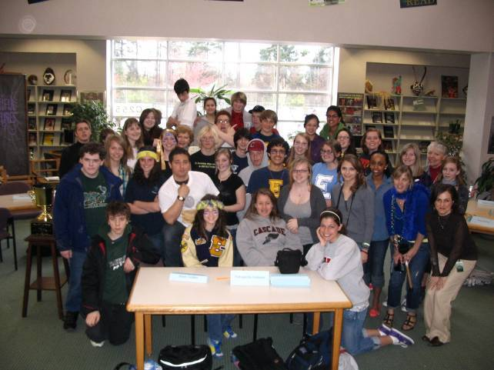
The Battle of the Books is a reading incentive program designed to encourage students to read quality literature.

It all began in the 1930’s as Chicago Radio program; today it is a reading incentive program in elementary, middle and high schools across America. As far as I know, just the high school librarians in this district have chosen to get on board this school year when one of our extraordinary teacher-librarians, Deb, Payne, of EHS, asked the three of us to join in the competition amongst ourselves last summer. Deb got a grant to do this at Everett High.

All three librarians, with their principals’ permission, then needed to purchase 5 copies of each of the 23 novels on the list that Deb chose for us to consider.
We procured these paperback from the Barnes & Noble @ Alderwood, as the public relations person there, Ms. Yadro, offered free delivery, free bookmarks-with the list of all the books-and even came to our schools to help us process the books and help the librarians get the questions together for the “individual battles” that were held on March 12th at each of the three high schools, eliminating all but the winners: 3 teams from each school.

At Cascade High School, one of the honors English teachers, Kelly Rogers, chose to be part of the fun and encouraged her two 9th grade English classes to participate. Cascade’s parent group, the Bruin Partners, supported these students with Alfy’s pizza and one third the cost of the school bus to JHS’s big Battle tomorrow.

Cascade High students had such fun that yet another teacher signed up for another Battle this June. Ms. Carole Woods’ ninth grade honors’ classes will also compete on June 9th in the CHS library.

After each school’s preliminary battle, pizza was served to all the student participants, and certificates and prizes were awarded. Barb has arranged for a trophy upon which will be inscribed the winning school’s name. This trophy will be proudly displayed in the trophy case of each year’s winning school

The Battle books were compiled from the 2010 nominees from the following awards: The Evergreen Young Adult Book Award, and the Young Reader’s Choice Award, Intermediate and Senior divisions.

Additional library news-

Everett High School Library

Readers' Cafe: A monthly book session to talk about our favorite books over snacks. *Funded by Blue and Gold
Writers' Cafe: Students got to meet two authors and participate in a writers' workshop with them. *Sponsored by the Alderwood Barnes and Noble.

EHS-NMS Book Club: Students and staff members from both schools read, discussed and celebrated The Hunger Games. *Funded by the Everett Public Schools Foundation
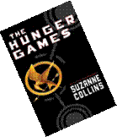
A review of the North and EHS Hunger Games Event
Written by Miranda Cooper, 9th grade participant

In the aftermath of a brutal war in North America, the nation of Panem, on shining Capital surrounded by twelve districts, rose from the ashes. When rebellion failed against the Capital, the twelve districts were punished. Now, every year, each district must send two tributes, one boy and one girl between the ages on twelve and eighteen, to the Capital to compete in the Hunger Games. In the Games, the teens are sent to an arena to fight the other twenty-three competitors… to the death. Now Katniss, an archer from District twelve, after stepping up to take her sister’s place in the games, finds herself in a world of glamour, strategy, deception, love, and death. Here, Katniss will have to decide what is real, and what’s all just part of the games.

In our event, we divided the teens into groups, assigning then each to a district randomly. From there, they participated in different activities, three of their choice, to try and earn as many points as possible. The activities tested the teens on different skills, such as balance, aim, speed, agility, focus… The people with the most points won the second book to the Hunger Games series.

Following that, the teens were transformed into Stylists, and given twenty minutes to design a Peep to look like any character from any point in the book. They were given many supplies such as cloth, beads, pipe clears, ex., to do this. When completed, every teen showed their creation to everyone there, then votes were cast as to which was the best. The top two with the most votes won the third book pre-ordered of the Hunger Games series.

Also supplied was a lot of good food. :) There was pizza, cookies, brownies, fruit, and some green stuff too (hardly touched).

Overall, it was so much fun!! Everyone had a great time and said they would love to do it again.

Staff Book Study Groups: Staff members read and discussed The Brain Rules by Medina and Readicide by Gallagher *Funded by the Everett Public Schools Foundation

Jackson High School Library

Readers’ Café is held once a week in the library during lunches. Students may bring their lunch, a book to share and friends to discuss a favorite book. Cocoa and pretzels are provided as students sit and talk about great reads.

Book Fair- JHS PTSA works to provide a fall Book Fair during the week JHS has Curriculum Night. Student volunteers work with the PTSA volunteers to help set up and take down the fair as well as assist students selecting books during their lunches. The Fair is open before, during and after Curriculum Night so parents may shop. Teachers are encouraged to pick a wish list of books from the fair, and part of the proceeds goes to provide books for the teachers, the rest goes for books in the library.

Author Events- Thanks to community partner, University Book Store, JHS students have been able to meet and greet numerous famous authors. Author links are on the JHS Library home page @ http://cms.everett.k12.wa.us/jacksonhigh/bstolzen/

JHS Reads Newspapers! If you need to know what is happening in the news, you can always stop by the table in front of Jackson High’s library. Thanks to the Everett Herald and Newspaper in Education, JHS receives daily stacks of the Everett Herald for student and staff use. Special education students bring the newspapers from their drop spot in front of the school to the library table, then work to deliver many newspapers to school offices, and classrooms.

